** Please use this template to complete your Multimedia project report **
(Don’t forget to remove these instructions before submitting!!)
NOTE: You can find some sample projects at the top of your Moodle page, if you wish to look at these for reference

DIGITAL MULTIMEDIA
PROJECT REPORT

** Insert Project Name Here **

PROJECT TEAM
Student No | Student Name
X17347773 | Tijesu Olalekan
X17342373 | Abraham Marcus Alabi
X17366481 | Christopher Angbalu
X17515503 | Anthony Denpsey

***** CA2: Pre-production Report ******************************************
NOTE: Sections 1, 2, 3 & 4 should be completed BEFORE any production begins on the project
- Any references for the pre-production report should be included in the bibliography at the end of this document

- Overview

** This should give an overall introduction to your project, outlining your project concept/idea, looking at what your initial plans for the project are, how you propose to develop your idea, etc. **

RESEARCH

** The research report should investigate a minimum of 3 similar productions. Your findings should include any relevant details of the similar projects, such as what the competing project is, why you chose this project to research, how it is different/similar from your project idea, etc. This should also include your team’s reflection on each competing production, saying what you liked/disliked and whether anything inspired your own project. **

NOTE: Don’t forget to reference any third-party material at the end of the document!

SCRIPT

** Include script for your project here, include as much information and detail into your script as you feel necessary. **

STORYBOARD

Story
Love triangle between Elijah Nathaniel and clementine.
Clementine is in love with Elijah, but Nathaniel has been in love with clementine for time.
Elijah is Nathaniel best friend who soon kills Nathaniel in a heated argument which
Elijah raps the body up put in his 4by 4.
They hide the body in the forest but clementine drops he pink glove at the burial site.
A dog-walker his dog of the leash and the dog follows the scent of the blood from the body and the dog walker follows after finding the glove and the dog start digging to be continued…
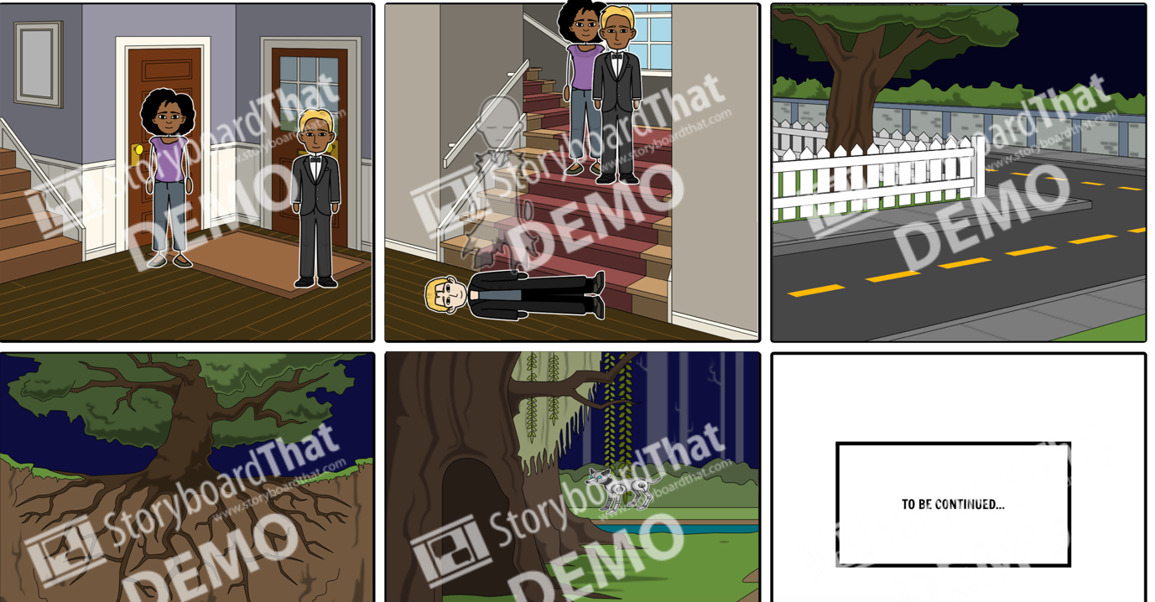

**********************************************************************************

** CA3: Production & Post-production Report ***************************
NOTE: Sections 5, 6 & 7 should only be completed AFTER the project is finished
- Don’t forget any references / bibliography

- TECHNICAL REPORT

** This section should outline what your initial project concept was and how you went about developing it into the final production. This should include all relevant development details, such as which methods you chose, i.e. video/animation/etc. and how you produced them, e.g. image editing process, animation development, video production, etc. You should also outline any technical details, such as errors or development issues. **

- PROJECT TEAM

** How did the project team break up the tasks required? Who did what tasks? Did everyone evenly participate? Were there any team issues? Etc. **
PLEASE NOTE: You will also be asked to peer review your team mates after submission

- CONCLUSION

** AFTER COMPLETION, looking back, how did the project go? Did you achieve what you set out to do? Are you happy with the results? Is there anything you might change if you had more time? Etc. **

*********************************************************************************

REFERENCES / BIBLIOGRAPHY

** ALL references should go here – if in doubt, reference it!!

MUST BE HARVARD REFERENCING SYSTEM OR MARKS WILL BE LOST!!! **

NOTE: See resources provided on Moodle on how to reference using Harvard System, if needed

